1) Run "Maris Guard" and click on "Go to web":
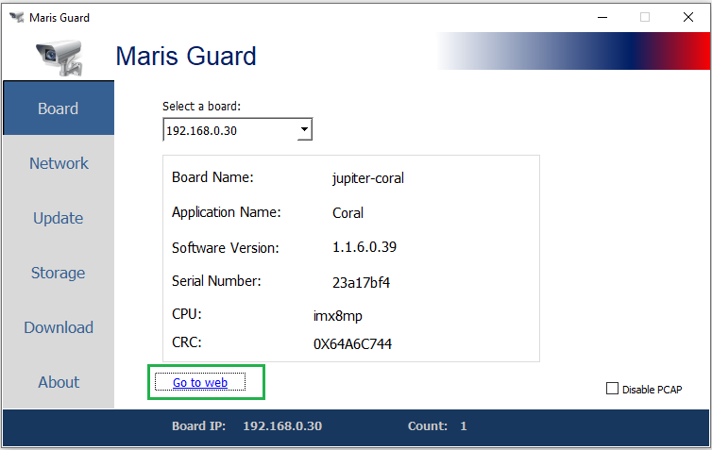
2) Open "General Setup" -> Recording and Cameras:
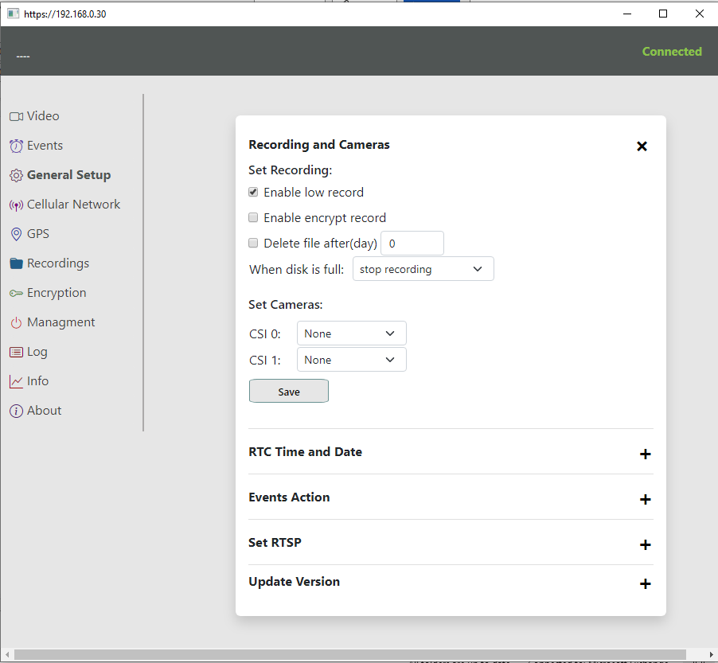
Set cameras for CSI0 and CSI1 that you have (for example analog and hdsdi) -> Save:
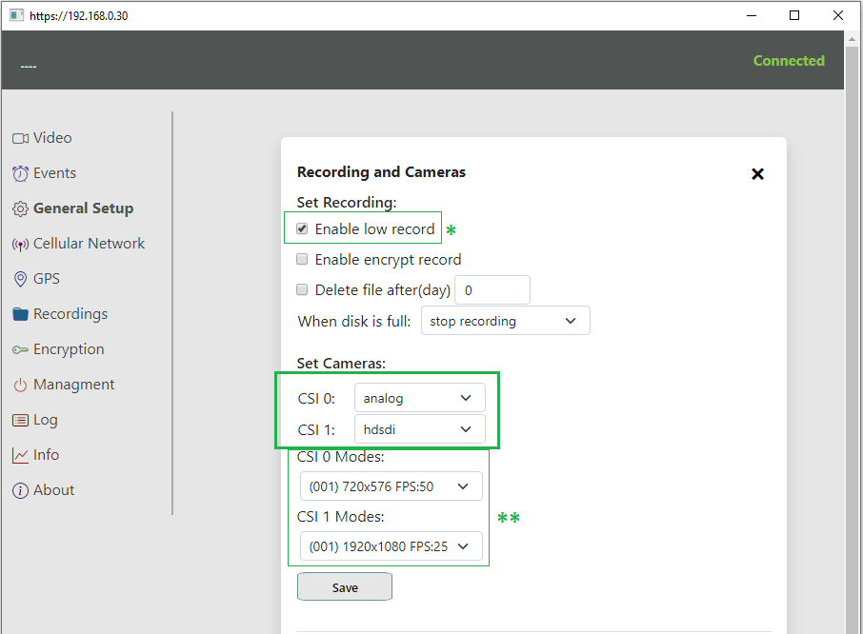
* If this option is checked, while recording, two files will appear: normal and small size (better compression).
** Once the cameras are identified by the board, fields with the resolutions of these cameras will appear below.
3) Set time and date ( "General Setup" -> "RTC Time and Date"):
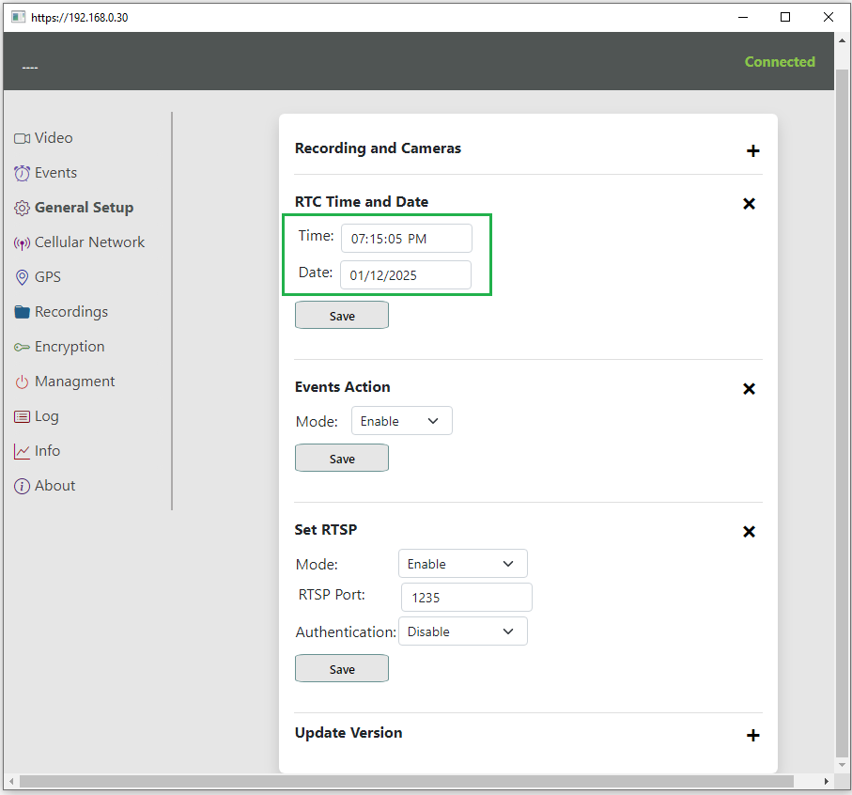
“Events Action” mode allows to enable/disable all Events functionality.
“Set RTSP” allows to set parameters for RTSP protocol (relevant in case of cellular network mode).
4) Open “Video” tab and set parameters for camera’s streaming or recording:
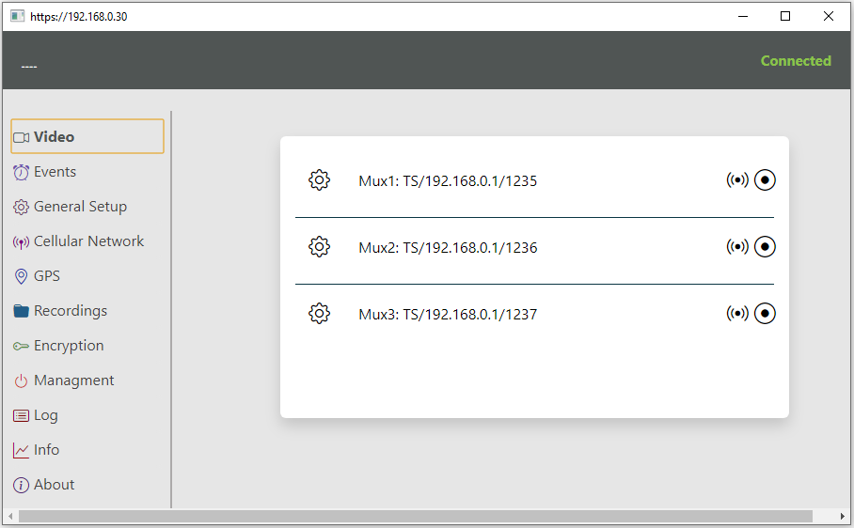
Select camera, protocol, IP address, network port and streaming or recording parameters:
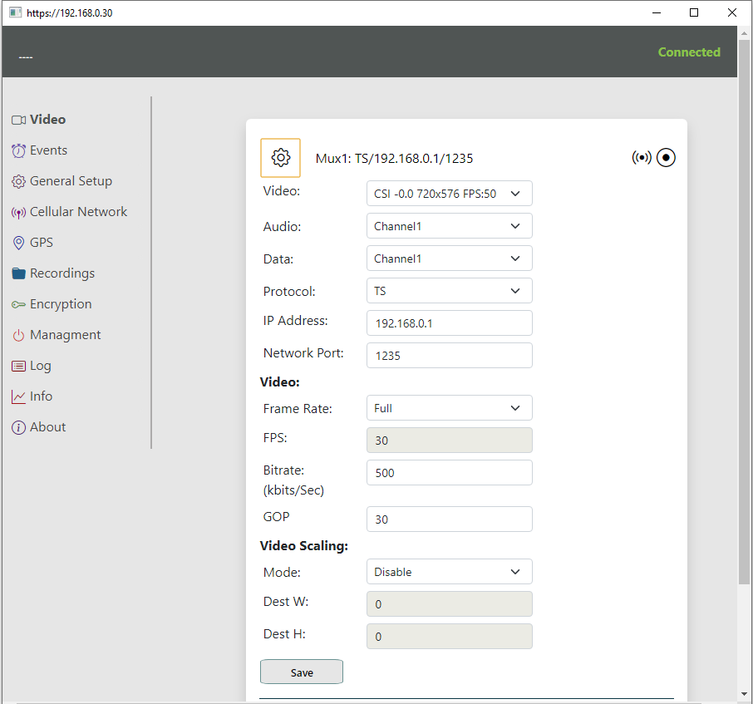
It is possible to define up to 3 cameras:
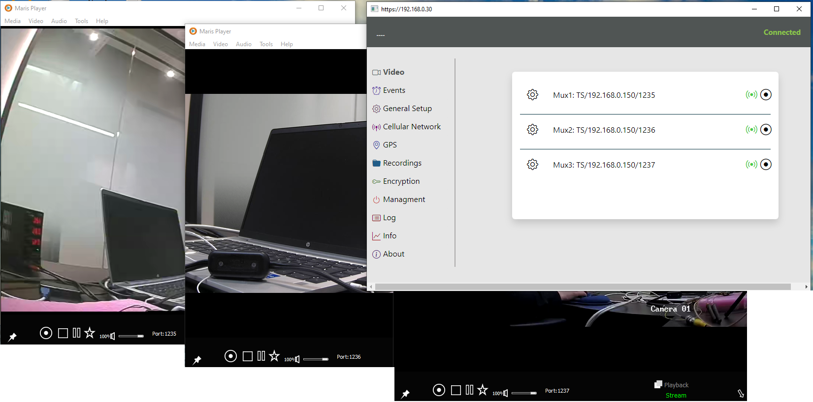
Note: For IP cameras need to use the same URL like in VLC network streaming.
For streaming from an IP camera via the RTSP (Real-Time Streaming Protocol) in VLC, the URL is built according to the following formula:
rtsp://<username>:<password>@<IP-address>:<port>/<path>
Where:
- <username> — the username for accessing the camera (if required).
- <password> — the password for accessing the camera (if required).
- <IP-address> — the IP address of the camera on the network.
- <port> — the port used for RTSP (default is usually 554).
- <path> — the stream or path provided by the camera (e.g., /h264, /stream1, etc.).
An example URL might look like this:
rtsp://admin:12345@192.168.1.100:554/stream1
In this example:
- admin — the username.
- 12345 — the password.
- 192.168.1.100 — the IP address of the camera.
- 554 — the RTSP port (default).
- /stream1 — the stream path on the camera.

5) Open “Events” to define events and respective actions:
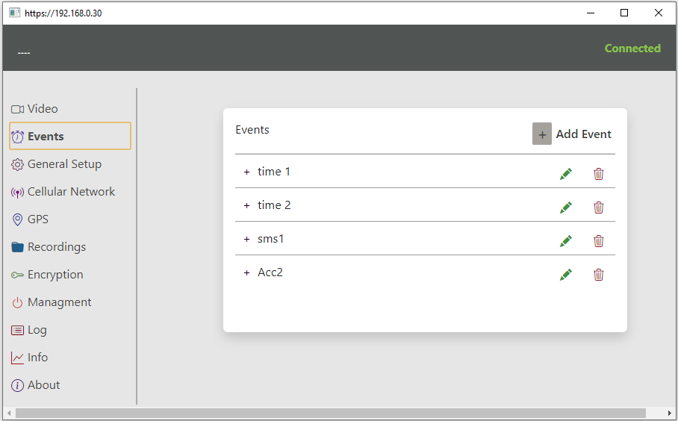
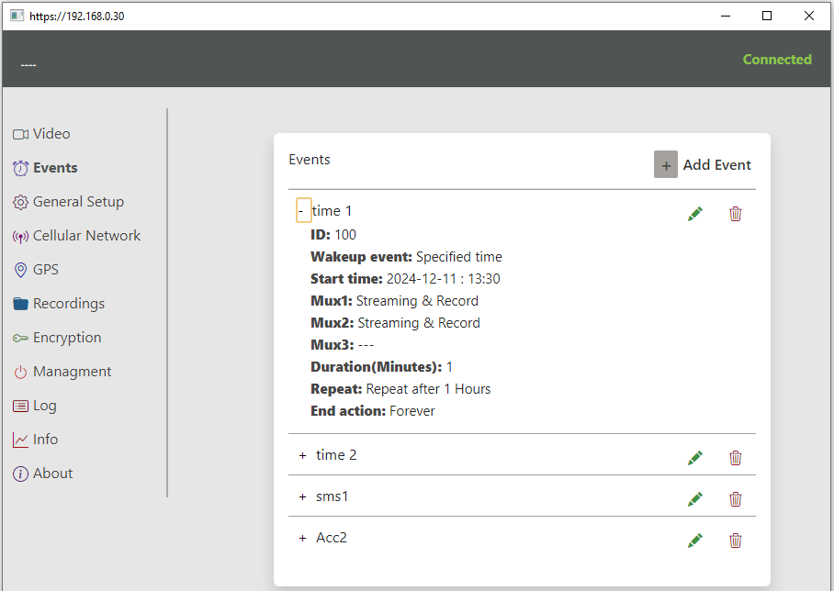
Here is an example:
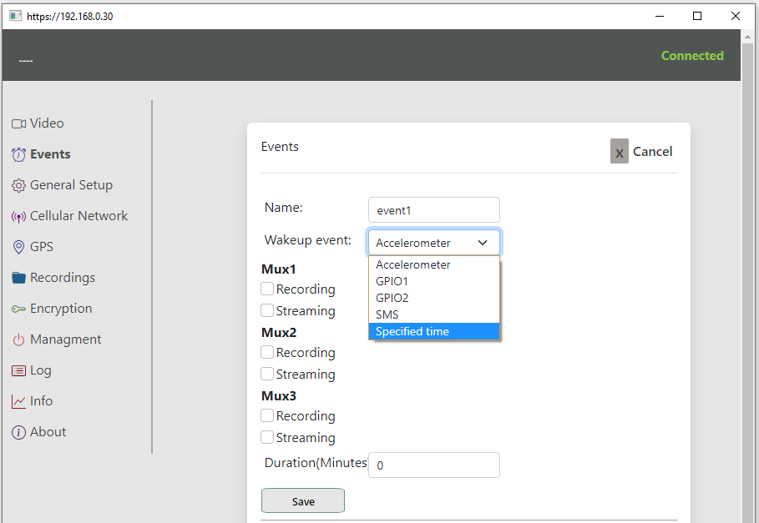
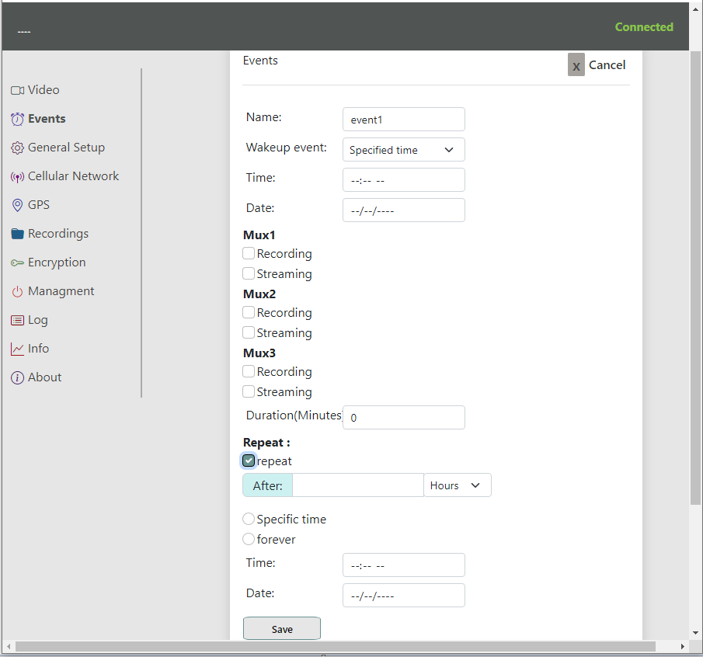

6) “Cellular Network” parameters:
Important note: checking on “Disable Ethernet” will not allow connection to the board via wired Network connection (cellular Network only). Connection via cellular is only possible with static IP of the SIM card.
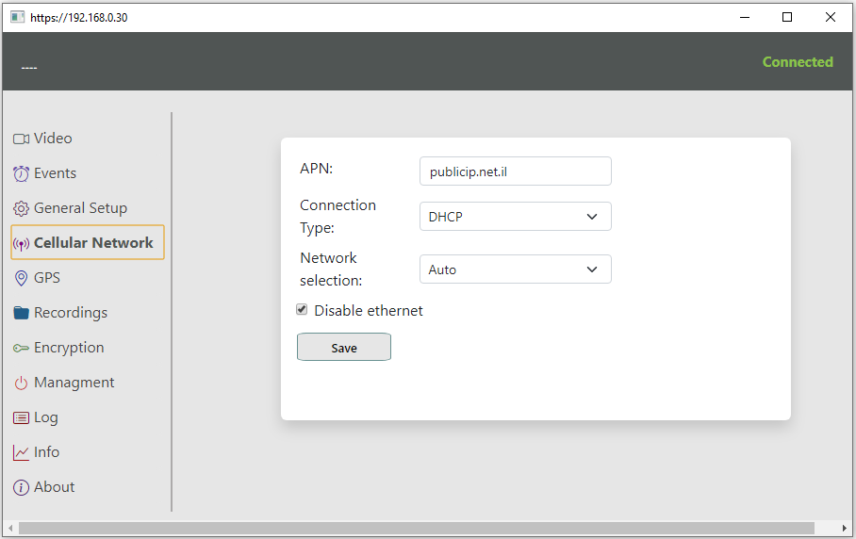
Note: There are instructions how to switch to the cellular mode (with SIM cars only) at the end of the document.
7) Setup GPS parameters:
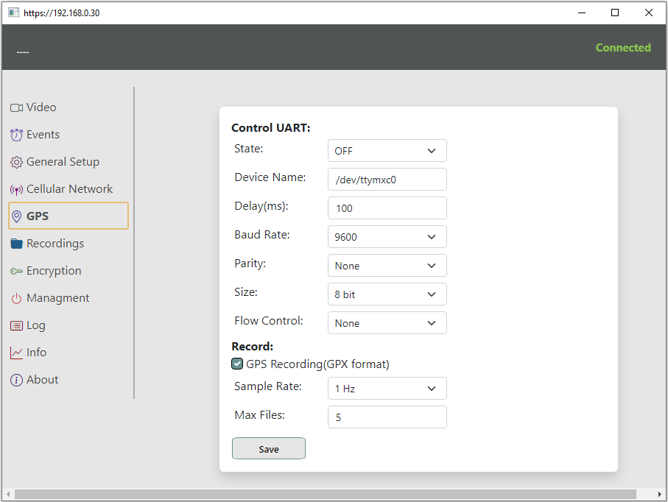

8) Recordings:
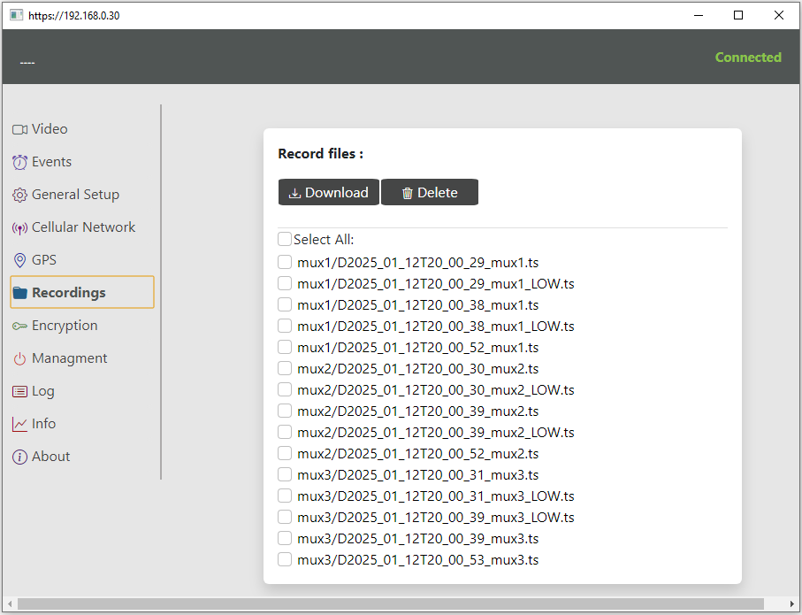
9) Management:
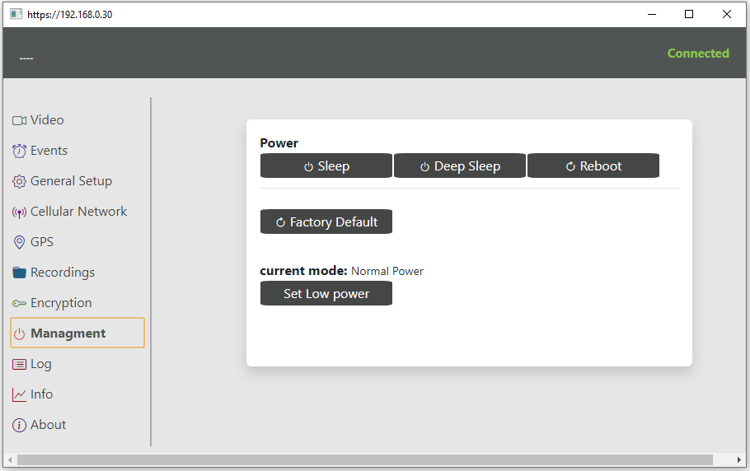
“Sleep” puts the board into sleep mode, any event will wake it up.
“Deep sleep” puts the board into deep sleep mode, only special time or accelerometer will wake it up.
Note: Now resuming power after power down will be treated as an event. And the board wake up from the both modes of sleep.
“Reboot” - reboot the board.
“Low Power” mode sets the board in the mode lower power usage.
10) Information:
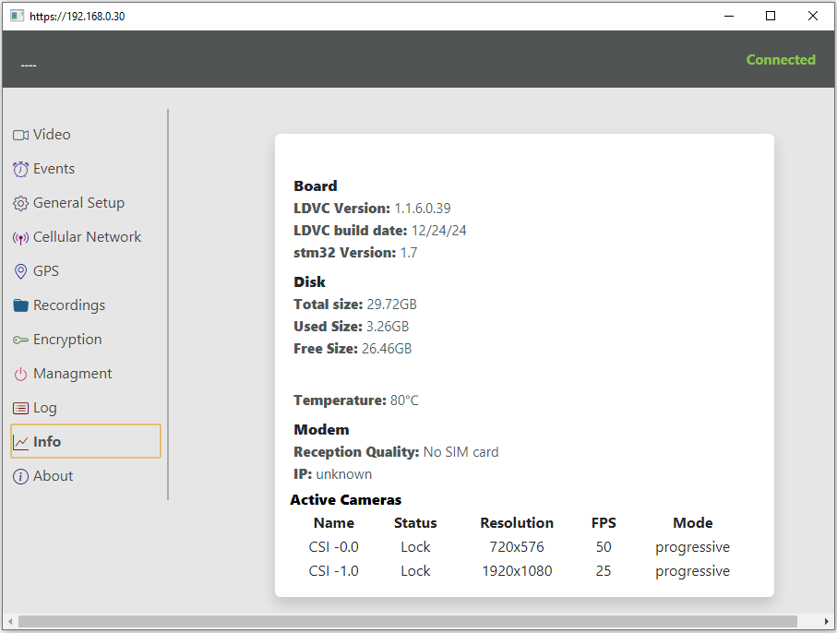
How to switch to the cellular mode (with SIM card only):
Important: you need to know the static IP of the SIM card.
1) Open in the left menu the tab "General Setup" -> Open "Set RTSP" -> Change the port number to 8554 -> Save
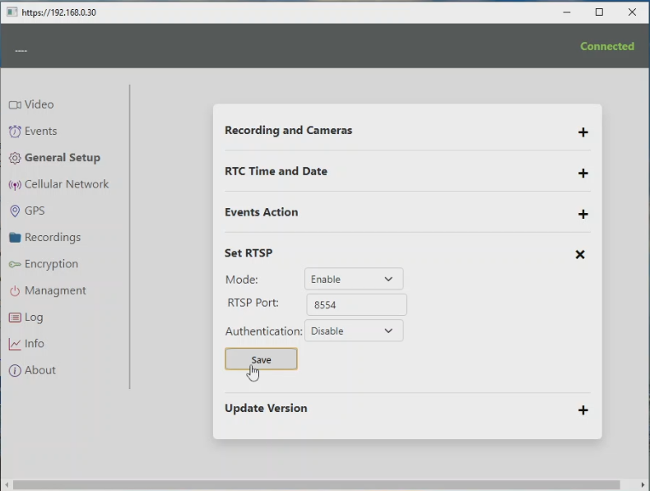
2) Insert the SIM card into the board
3) Disconnect the Ethernet cable (optional, can be done later)
4) Reboot the board
5) In Chrome, enter the static IP of the SIM card and connect (you will probably have to open the window as "Not secure")
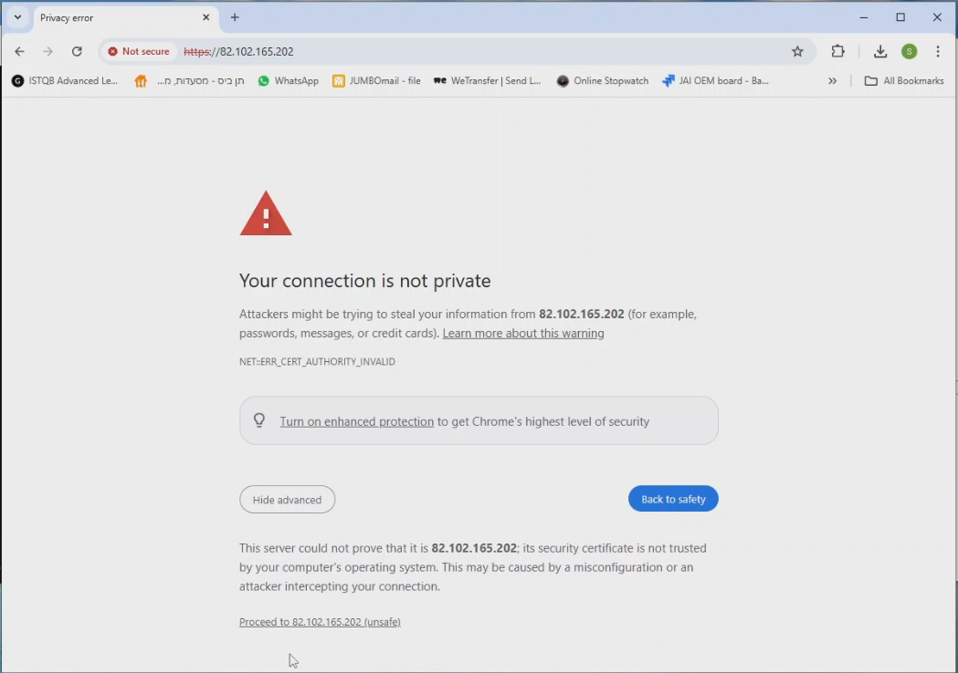
6) In the "Info" tab you can see the IP. Check in the "General Setup" that the RTSP port is: 8554
7) In the Browser, in the Mux that you are going to use, change the TS protocol (default) to RTSP -> Save
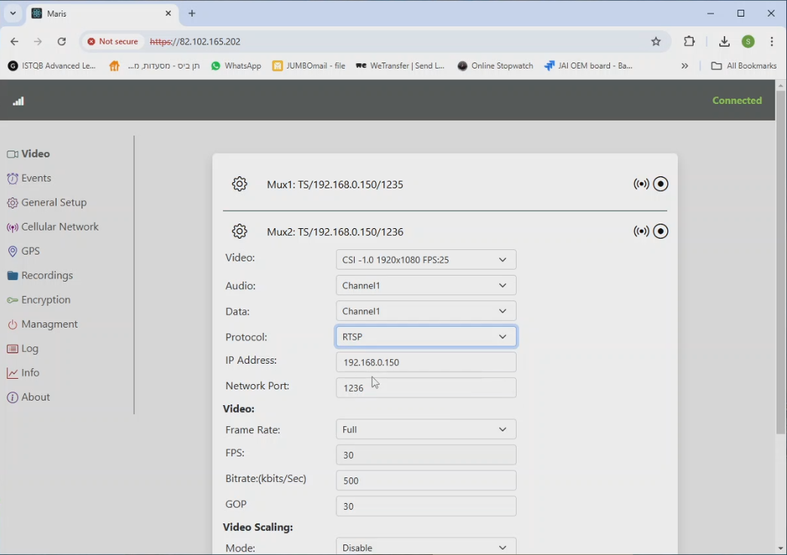

8) Run Maris Player.
In Network Streaming, select the RTSP protocol, URL(IP) = static IP of the SIM card, SDP = the MUX number that is used (for example, for MUX 2, you need to write mux2.sdp), enter the port 8554 => Press "Play"*
*In the Browser, in MUX there is no need to activate Streaming, since it is initiated from Maris Player
